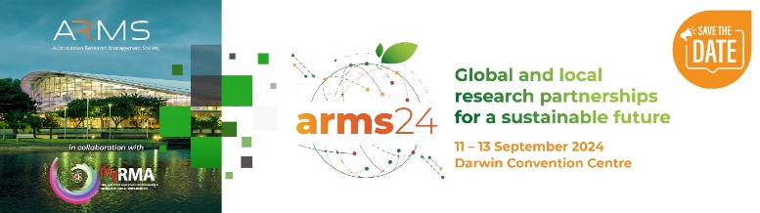
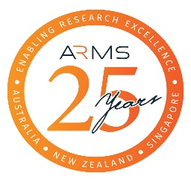
APPLICATION FORM
FOR CHAPTER TRAVEL AWARD TO ATTEND
ARMS DARWIN CONFERENCE 2024

INSTRUCTIONS:
- Complete this Application Form.
- Attach your organisation’s letter of support OR your self-employed statement.
- Email the Application Form and support letter or self-employed statement, combined into a single pdf document, to ARMSmembership@researchmanagement.org.au by no later than 5 PM AEST, 19 April 2024. Please note that late or incomplete applications will not be accepted.

PERSONAL DETAILS:
Your Name
Your Chapter
Your Position
Your Organisation
Phone |  | Email

ELIGIBILITY CRITERIA:
I am a financial member of ARMS (as an individual or part of a corporate membership) | yes no
Evidence of support:
I have attached a letter of support from my employer OR* | yes no
I am self-employed and have attached a supporting statement* | yes no
I have not been previously received an ARMS Chapter Travel Award in the past five years. | yes no

*Supporting statement must also include the level of financial assistance to be provided by the employer or the individual to support their attendance to the 2024 conference. The letter must also describe how attending the ARMS Darwin Conference is relevant to the applicant’s current role.

ASSESSMENT CRITERIA:
Your application should address the following criteria, up to a maximum of three (3) pages in total.

- Your professional experience in the research management field and your career history over the last five years. Summarise roles held, key responsibilities and any challenges that you have faced during your career.

- The themes of the conference you are interested in and how they will contribute to your professional and career development.

- Benefit of attending the conference and how this will fit into your career aspirations.

- Brief budget justification for the amount of support being requested including a description of how other costs not met through the travel Award will be covered.

